Road Closures - Half Marathon & 8k

On the morning of Sunday, October 10 over 4,500 people will participate in the Royal Victoria Half Marathon and 8K Road Race. The races (8k Start – 7:30 am and Half Marathon — 9:30 am) both start and finish on Belleville between Oswego and Menzies Streets. Runners will finish running / walking both events at 1:00 pm.
The events will affect vehicular traffic in the following areas: Downtown, James Bay, Cook Street, Beacon Hill Park, and Fairfield/Gonzales. Police, city staff and race organizers are working to ensure a safe route for the participants and the community. Residents and commuters should expect delays, and be prepared to use alternate routes. Times for road closures are approximate. Roads will be reopened on a rolling schedule as the participants pass through the various neighbourhoods.
Important: No parking is allowed on the race route. No parking, special event signs will be put up in the City of Victoria and cars will be towed from the course on Sunday morning between starting at 3 am.
Extended complete closures for set up, use, and take down of start, finish, recovery and support areas.

Saturday, October 9th
1400 – 2400 | Belleville between Oswego and Government  Menzies between Belleville and Quebec
Sunday, October 10th
0000 – 1800 | Belleville between Oswego and Government
0400 – 1300 | Dallas between Cook and Ogden Point
0300 – 1500 | Menzies between Belleville and Superior
Full rolling closures will be in place along the race routes while runners pass — approximate closure times are in the following schedule and are in addition to those noted above.

Set up of cones, pylons, signs and aid stations along the course will start at 3 am, with take down immediately following the last runner. Please slow and pay attention to police, traffic control personnel, road marshals, cycling officials, and volunteers as they are focused on keeping the participants and general public safe.
There is no parking or driving on the route from 3 am to 1 pm on Sunday, Oct 10th and extended closures on Belleville between Government and Oswego to accommodate the set up and take down of the start / finish line infrastructure.

Sunday, October 10, 2021
FULL closure during the following times
Intermittent closures may be enforced outside of these times
0700 to 1330 | Belleville, Pendray, Quebec, Montreal, Kingston, St Lawrence, Erie, Dallas
 | Dallas Road: Ogden Point to Cook Street
 | Beacon Hill Park including Park and Heyward
 | Cook St from Chapman to Dallas Road
0950 to 1200 | Ross Bay Cemetery to Fairfield Road
0955 to 1130 | Fairfield Road to Quamichan

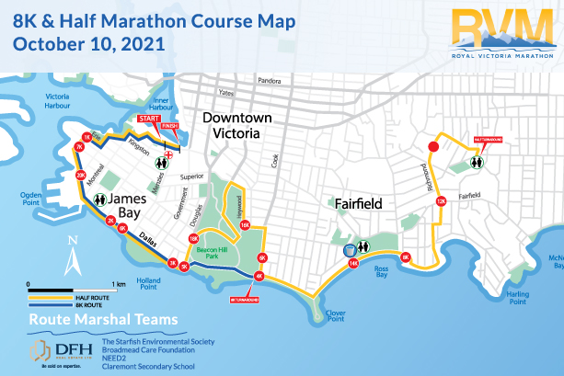

Predicted Finishing Times:

Race | Start | First Finisher | Peak Finishing Times
8K Road Race | 7:30 a.m. | 7:53 a.m. | 8:00 a.m. – 8:30 a.m.
Half Marathon | 9:30 a.m. | 10:36 a.m. | 11:10 a.m. – 11:50 p.m.

Thank you very much for your understanding and support of all the participants and the volunteers.

For More Information on the Royal Victoria Marathon, please visit our website at www.runvictoriamarathon.com E: info@runvictoriamarathon.com

